**Department of Computing**

**SE-312: Software Construction**

**Class:** BESE-7AB

**Lab 12: JFLEX Parser**

**Date: May 6th, 2019**

**Instructor:** Dr. Seema Jehan

GROUP MEMBERS

## **Aena Hassan 196164**

## **Imama Jawad 199244**

## **Hiba Akram 175446**

**Lab 12: Bison Parser**

**Introduction:**

Students will have hands-on experience of Bison parser.

**Group Size**: 3-4 students

Material:

<http://www.gnu.org/software/bison/>

<http://www.gnu.org/software/bison/manual/bison.pdf>

**Lab Tasks**

**Githhub link:**

<https://github.com/ImamaJawad/Lab_12>

Install Bison parser generator tool. Execute calculator example given in the manual and generate parse trees for few valid inputs.  
Installation on LINUX UBUNTU

In order to install the latest bison parser we download bison-3.3 tar file. from the link and installed the C language compiler in our OS. In the second step, we ran the following commands in the bison source folder

**./configure**

**make**

**make install**

After this bison-3.3 was successfully installed and which we checked as follows:

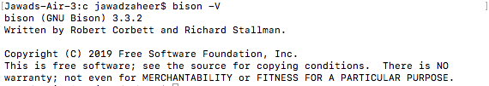

Steps for parsing various calculators

* In order to use bison for the different calculators we first of all run bison filename.y, which creates a parser for the grammar file with .y extension
* In the second step we run cc -lm -o filename filename.tab.c on the files to create a filename to run the parser for different expressions.
* Finally ./filename to run the calculator and pass it different expressions. We show the different calculators on which we have run this example.

**Examples:**

# PostFix Calculator (rpcalc)

This calculator parses the postfix expressions and evaluates their answers. Following screenshots show some valid and invalid expressions.

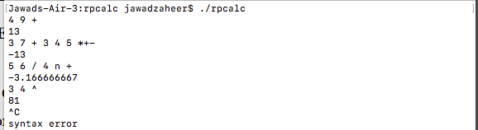

Note that it gives syntax error for invalid inputs.

# Infix Calculator (calc)

This calculator parses the infix expressions and evaluates their answers. Following screenshots show some valid and invalid expressions.

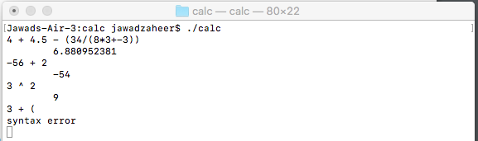

# Multi-Function Calculator (mfcalc)

This calculator evaluates sin, cos, ln and other functions in addition to previous ones.

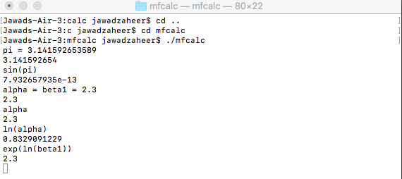

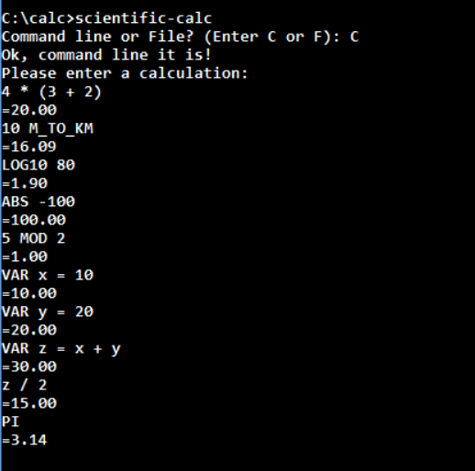

Conclusion

We have successfully installed the parser, which is basically the bison parser which generates a parser using the. y file extension file containing the grammar and hence, accepts different expressions and then parses them. It gives an answer after performing an evaluation.